WEST SAINT MARK BIBLE COLLEGE & SEMINARY
CHURCH MEN | NEWSLETTER  August 2026 Issue • SECOND QUARTER
FAITH FAMILY LEADERSHIP FELLOWSHIP
CHURCH MAN  OF THE QUARTER  A LIFE  BUILT TO  SERVE  Faith. Family. Leadership.  BROTHER  LARRY D. HARPER | 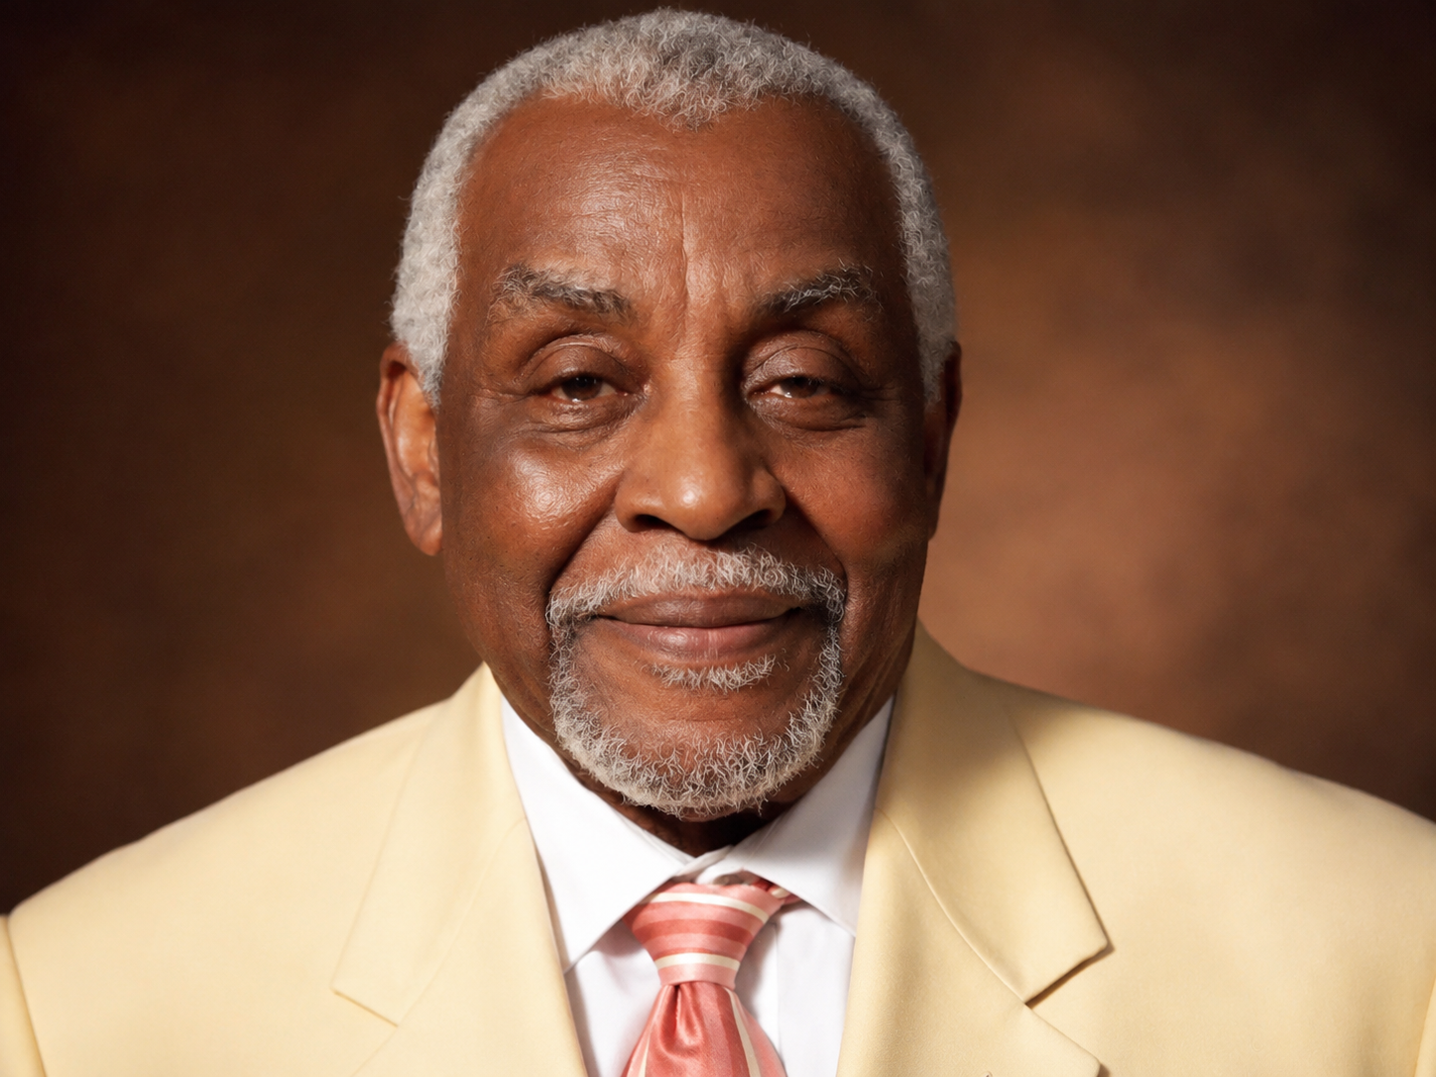
FEATURED IN THIS ISSUE
Built to Serve: Faith, Family & Leadership | DISCIPLES OF CHRIST  WALKING UPRIGHT
LEADING WITH CONVICTION • LOVING WITH PURPOSE • LIVING AS DISCIPLES

FROM THE CURRENT ISSUE

Whole Men. Strong Families. Faithful Service.
Church Men encourages men from their teenage years through adulthood to stand firmly in faith, lead responsibly at home, serve their communities, and build a legacy that honors God.
THEME SCRIPTURE
Be ye followers of me, even as I also am of Christ. - 1 Corinthians 11:1, KJV

Inside This Newsletter
- Church Man of the Quarter: Brother Larry D. Harper
- A Black Father’s Charge to Sons, Daughters, and Generations
- Restoring Our Community One Relationship at a Time
- Counsel from a Senior Adviser to Young Black Men
- Faith & Family: Leading First at Home

Our Purpose
The Church Men newsletter offers practical encouragement for fathers, husbands, mentors, community leaders, church workers, and young men of faith. Its message is rooted in Scripture and lived with dignity: faith that stands firm, brotherhood that builds, and leadership that serves.

MEN OF HONOR

Church Man of the Quarter
BROTHER LARRY D. HARPER
Honoring Brother Larry D. Harper
Church Man of the Quarter
We proudly honor Brother Larry D. Harper as our Church Man of the Quarter—a mature, experienced, and steadfast man of faith whose life reflects the transforming power of God.
Brother Harper’s spiritual foundation was laid during childhood, when his mother faithfully instructed him in the Word of God and guided him in the ways of the Lord. Like many believers, however, he eventually had to know God for himself. The truths planted in his youth were tested and confirmed through firsthand experiences, persistent prayer, growing faith, humility, and complete dependence upon God.
By surrendering his life to Jesus Christ as Lord, Brother Harper became a man of strength, courage, wisdom, and spiritual conviction. He delights in God’s Word daily, seeks the guidance of the Holy Ghost, loves the Lord sincerely, and demonstrates deep compassion toward others—whether friend or foe.
Brother Harper endeavors to live a life that is pleasing to God. He remains mindful that because God is his Father, every word he speaks and every action he takes should honor and glorify Him. Even before Brother Harper speaks, his gentle smile, soft and gracious voice, dignified appearance, and quiet manner bear witness to his close relationship with Christ.
His desire is now to pour into the next generation. Brother Harper seeks to pass on to young men the biblical instruction he received, along with the wisdom, discipline, and spiritual maturity he has gained throughout his walk with the Lord. He wants them to understand that godly manhood is developed through faith, obedience, prayer, humility, perseverance, and surrender to Christ.
Brother Larry D. Harper is an upright church man whose life provides an example worthy of following. He does not merely speak about faith—he strives to live it. Others may confidently follow his example because he is committed to following Christ.
“Be ye followers of me, even as I also am of Christ.” —1 Corinthians 11:1, KJV
We gratefully recognize and celebrate Brother Larry D. Harper as our Church Man of the Quarter.
Faithfully Submitted, Bishop Dr. Timothy Peppers West Saint Mark Church of Christ (Disciples of Christ)

FEATURE 01 | SPIRITUAL LIFE

A Black Father’s Charge to Sons, Daughters, and Generations
KEY TRUTH
A father's strongest sermon is often preached without a pulpit.

By a Church Man, Father, and Man of Faith
Being a father has taught me that children listen to our words, but they study our lives. They notice how we respond when money is short, when people disrespect us, when plans fail, and when our faith is tested. A father’s strongest sermon is often preached without a pulpit.
The Bible says, “The just man walketh in his integrity: his children are blessed after him” (Proverbs 20:7, KJV). Integrity means being the same person at home that we claim to be in public. Our children need fathers who pray, apologize, keep their promises, respect women, work honestly, and remain faithful when life becomes difficult.
As a Black father, I understand that young Black men face pressures that others may not always recognize. They may be judged before they speak, feared before they are known, or underestimated before they are given an opportunity. I have had to teach young men that unfair treatment must never become an excuse for destructive behavior.
Your anger may be understandable, but it must not become your master. Scripture warns, “He that hath no rule over his own spirit is like a city that is broken down, and without walls” (Proverbs 25:28, KJV). Self-control is not weakness. It is the strength to decide that another person will not control your future through your emotions.
Young men, there may be moments when someone tries to provoke you. Walking away may save your education, employment, freedom, or life. You do not have to answer every insult or accept every invitation to fight. “A soft answer turneth away wrath: but grievous words stir up anger” (Proverbs 15:1, KJV).
A father must also teach responsibility. You cannot build a meaningful life by blaming everyone else. Racism, poverty, family wounds, and limited opportunities are real, but God can still give you wisdom to move forward. Joseph was betrayed, falsely accused, and imprisoned, yet he refused to surrender his character. What others intended for evil, God used for good (Genesis 50:20).
Education matters. Honest work matters. Learning a trade matters. Saving money matters. Choosing friends wisely matters. But above everything else, your relationship with God matters. Jesus asked, “For what shall it profit a man, if he shall gain the whole world, and lose his own soul?” (Mark 8:36, KJV).
I have learned that providing for a family involves more than paying bills. A father must provide affection, correction, direction, protection, and spiritual leadership. Children should not have to wonder whether their father loves them. Tell them. Show them. Spend time with them. Listen before giving a lecture.
If you are a father who made mistakes, do not allow shame to keep you absent. Return. Apologize. Rebuild trust patiently. You cannot change yesterday, but with God’s help, you can become dependable today. “A just man falleth seven times, and riseth up again” (Proverbs 24:16, KJV).
To young men who grew up without a present father: your beginning does not have to determine your ending. God can place pastors, coaches, teachers, uncles, deacons, and responsible older men in your life. Receive wise instruction. Do not let the absence of one man prevent you from learning from another.
Paul told Timothy, “Let no man despise thy youth; but be thou an example of the believers, in word, in conversation, in charity, in spirit, in faith, in purity” (1 Timothy 4:12, KJV). You do not have to wait until you are older to become an example.
My charge to every young Black man is simple:
- Know God before the world tries to define you.
- Respect yourself and others.
- Guard your name and reputation.
- Control your temper.
- Develop your mind and abilities.
- Choose friends who strengthen your future.
- Honor women and protect children.
- Accept correction without surrendering your dignity.
- Become the man you once needed in your own life.
Faith that stands firm is not faith that never experiences trouble. It is faith that refuses to collapse under trouble. Build your life on Christ, because everything else can change.
Jesus said, “Therefore whosoever heareth these sayings of mine, and doeth them, I will liken him unto a wise man, which built his house upon a rock” (Matthew 7:24, KJV).
Stand on that Rock. Let your character speak. Let your faith endure. Then allow the next generation to be blessed because you chose to walk upright.

FEATURE 02 | LET US BUILD TOGETHER

Restoring Our Community One Relationship at a Time
KEY TRUTH
Our young men need consistent relationships before trouble begins.

A Community Leader's Perspective
A healthy community is not created by buildings alone. It is built through relationships, responsibility, trust, sacrifice, and shared purpose. Streets improve when people living on them decide that every child matters, every elder deserves respect, and every man has a responsibility beyond himself.
Scripture asks, “Am I my brother’s keeper?” (Genesis 4:9, KJV). The answer our community must give is yes.
Over the years, I have watched young people succeed when responsible adults took an interest in them. Sometimes it was a coach who would not allow a student to quit. Sometimes it was a pastor who helped a young man find employment. Sometimes it was a neighbor who corrected a child and then walked him home safely.
I have also seen what happens when good people remain silent. A community suffers when responsible men stay inside while gangs recruit outside, when experienced workers refuse to mentor beginners, or when successful people forget the neighborhoods that helped form them.
Our young men need more than speeches after trouble occurs. They need consistent relationships before trouble begins.
The Bible says, “Iron sharpeneth iron; so a man sharpeneth the countenance of his friend” (Proverbs 27:17, KJV). Iron does not sharpen iron from a distance. Growth requires contact, conversation, correction, and accountability.
Brotherhood is not simply calling someone “brother.” Brotherhood means helping him become better. A true brother will encourage you, but he will also warn you. He will celebrate your progress, but he will not applaud behavior that destroys your future.
Young men must learn to recognize counterfeit friendship. Anyone who pressures you to break the law, disrespect your family, misuse women, abandon school, or risk your future is not proving loyalty. “He that walketh with wise men shall be wise: but a companion of fools shall be destroyed” (Proverbs 13:20, KJV).
The people closest to you will influence your language, decisions, ambitions, and direction. Choose companions who discuss goals, faith, education, business, family, and service—not only entertainment, conflict, and appearances.
Our community must also restore respect between generations. Younger men sometimes believe older men cannot understand them. Older men sometimes criticize young people without listening to them. We need both wisdom and energy.
The elders possess lessons learned through struggle. Young people possess ideas, technology, creativity, and new ways of organizing. When generations work together, the entire community becomes stronger.
Paul instructed Titus that aged men should demonstrate sound faith, patience, and good character, while teaching younger men to be sober-minded (Titus 2:2–6). Older men must model what they teach. We cannot demand discipline from young men while living carelessly ourselves.
Community leadership begins with service. Jesus said, “Whosoever will be chief among you, let him be your servant” (Matthew 20:27, KJV). Leadership is not a title, photograph, reserved seat, or public recognition. It is accepting responsibility when no applause is offered.
A community-building man can serve in practical ways:
- Mentor one young person consistently.
- Help someone prepare for a job interview.
- Teach financial responsibility.
- Support local businesses.
- Attend school and community meetings.
- Check on elderly neighbors.
- Volunteer with a church or youth organization.
- Help resolve conflict peacefully.
- Encourage fathers to remain active in their children’s lives.
- Create opportunities instead of only discussing problems.
We must also protect our community from hopelessness. Young people repeatedly exposed to violence, poverty, addiction, and disappointment may begin to believe nothing will change. Our responsibility is to demonstrate that another path exists.
Jeremiah 29:11 says, “For I know the thoughts that I think toward you, saith the Lord, thoughts of peace, and not of evil, to give you an expected end.” God has not abandoned our young people. Therefore, we must not abandon them.
To every teenager: your community needs your gifts now. You can serve before you become an adult. Help younger children. Respect neighborhood elders. Participate in positive programs. Refuse to spread conflict through social media. Use your influence to strengthen rather than tear down.
To every adult man: somebody is observing you. A young man may never tell you that he admires you, but he notices how you treat people and handle pressure. Live so that following your example would lead him toward God, responsibility, and purpose.
Brotherhood that builds does not deny our community’s problems. It refuses to surrender to them. We may not repair everything at once, but we can begin with one block, one church, one family, one classroom, and one young man.
- “Two are better than one; because they have a good reward for their labour” (Ecclesiastes 4:9, KJV).

FEATURE 03 | SENIOR LEADERSHIP THE VOICE OF EXPERIENCE

Counsel from a Senior Adviser to Young Black Men
KEY TRUTH
The next generation needs Black men whose success becomes service.

Counsel from an Older Church Man
Young men often ask me how to become leaders. My first response is that leadership begins before anyone gives you a title. It begins with the ability to govern yourself.
Before leading a company, ministry, family, organization, or community, learn to lead your thoughts, habits, words, time, money, and emotions. Scripture says, “He that is slow to anger is better than the mighty; and he that ruleth his spirit than he that taketh a city” (Proverbs 16:32, KJV).
Life has taught me that talent may open a door, but character determines whether you remain in the room. Intelligence without discipline can be wasted. Charisma without integrity can become dangerous. Ambition without wisdom can destroy the very future you are trying to build.
I have watched gifted men lose opportunities because they arrived late, refused correction, spoke carelessly, or believed certain responsibilities were beneath them. I have also watched ordinary men become extraordinary leaders because they were dependable.
Be the man who arrives prepared. Return calls. Keep appointments. Complete assignments. Admit mistakes. Treat custodians with the same respect you give executives. Your habits introduce you before your résumé does.
Jesus taught, “He that is faithful in that which is least is faithful also in much” (Luke 16:10, KJV). Do not wait for a great opportunity before becoming responsible. Practice greatness in small duties.
Young Black men must also understand the power of presentation. You should not be judged unfairly by your appearance, but wisdom teaches us to consider the message our appearance sends. Dress appropriately for the setting. Speak clearly. Look people in the eye. Learn when to listen. Know how to enter a professional room without losing your cultural identity.
Daniel lived in a foreign kingdom, yet he remained disciplined, educated, excellent, and faithful to God. Daniel 6:3 says, “Then this Daniel was preferred above the presidents and princes, because an excellent spirit was in him.” Excellence gave Daniel influence, but his faith kept that influence from corrupting him.
You will encounter rejection. Every closed door is not proof that you are unqualified. Sometimes rejection redirects you. Sometimes it reveals an area requiring improvement. Sometimes it exposes injustice. Ask God for wisdom to know the difference.
Do not let rejection make you bitter. Bitterness consumes energy needed for growth. Learn the lesson, strengthen your preparation, and continue forward. “And let us not be weary in well doing: for in due season we shall reap, if we faint not” (Galatians 6:9, KJV).
Learn to manage money early. Your income does not determine your financial maturity—your decisions do. Avoid trying to impress people who will not help pay your debts. Save before spending. Understand credit. Invest in education, property, business, and useful skills.
Proverbs 21:20 teaches, “There is treasure to be desired and oil in the dwelling of the wise; but a foolish man spendeth it up.” Financial wisdom gives you options and strengthens your ability to help others.
Choose relationships carefully. The person you date or marry can influence your peace, purpose, faith, finances, and legacy. Do not select a lifelong partner based only on physical attraction. Look for character, spiritual maturity, emotional stability, work ethic, and shared values.
Treat women with dignity. Do not measure manhood by sexual conquest. Real manhood accepts responsibility, protects trust, honors commitment, and exercises self-control. “Flee also youthful lusts: but follow righteousness, faith, charity, peace” (2 Timothy 2:22, KJV).
Seek mentors, but do not expect a mentor to do your work. Come prepared with questions. Apply the advice you receive. Give progress reports. Respect the mentor’s time. A wise adviser can help you avoid mistakes, but he cannot substitute his discipline for yours.
There will also come a time when you must become a mentor. Knowledge becomes more valuable when it is shared. Do not climb the ladder and pull it up behind you. Reach back for another young man.
Jesus gave the clearest model of leadership when He said, “For even the Son of man came not to be ministered unto, but to minister” (Mark 10:45, KJV). Christian leadership is service with responsibility. My counsel to young Black men is this:
- Put God first.
- Protect your character.
- Master your emotions.
- Continue learning.
- Develop more than one useful skill.
- Save and manage money wisely.
- Choose relationships carefully.
- Accept correction.
- Serve before seeking recognition.
- Help another man rise.
You do not have to become famous to become significant. A faithful husband, present father, honest worker, dependable church member, trusted neighbor, and responsible citizen exercises powerful leadership.
Psalm 37:23 declares, “The steps of a good man are ordered by the Lord: and he delighteth in his way.” Allow God to order your steps. Walk with humility, discipline, courage, and faith.
The next generation does not merely need successful Black men. It needs Black men whose success becomes service.

FAITH & FAMILY

Leading First at Home
Practical encouragement for fathers, husbands, mentors, and men of faith must begin at home. Christian leadership is measured not only by public words, but also by private faithfulness, patient love, responsible provision, honest correction, and a daily example worthy of imitation.
A FATHER'S CHARGE
Let your character speak. Let your faith endure. Allow the next generation to be blessed because you chose to walk upright.

Stay Connected
Read the current issue and future updates at:
https://church-men-magazine.peppersdoc.chatgpt.site

Publication
Church Men
West Saint Mark Bible College and Seminary
Faith. Family. Leadership.
© 2026 West Saint Mark Bible College and Seminary

